For Everyone
  - Strategic Framework
06 February 2024
To find out more, please contact: Tiffany Lam
Tiffany.lam@sustrans.org.uk
Photo credit: Jonathan Bewley
We work for and with communities, helping them come to life by walking, wheeling and cycling to create healthier places and happier lives for everyone. www.sustrans.org.uk
Registered charity no. 326550 (England and Wales)
SC039263 (Scotland).

Contents
1
Document title over one line, maximum 15 words text text text text text
00 Month 2019
Key Concepts 2
Foreword 6
Executive Summary 8
Introduction 12
The case for our For Everyone agenda 13
About this For Everyone Strategic Framework 14
Internal 17
Employee Lifecycle 18
Governance & Leadership 19
Learning & Development 19
Policies 19
Culture 20
Communication 20
External 21
Safety & Wellbeing 22
Accessibility 23
Economic inclusion 23
Enablers 25
Next steps 26
Our Learning Approach 26

Key Concepts
Below are definitions of equity and related concepts. They are ordered logically, as some concepts are building blocks for others.

Diversity
Diversity is recognising, understanding and respecting individual identities and differences along social, cultural and economic dimensions. Beyond increasing representation of people from different backgrounds, diversity implies being able to relate to and work with people whose backgrounds, views and experiences are different from our own, without prejudice.
In the UK, the Equality Act 2010 guides diversity initiatives, with a focus on nine protected characteristics (age, disability, gender reassignment, marriage and civil partnership, pregnancy and maternity, race, religion or belief, sex, sexual orientation) and preventing discrimination on those grounds. It is important to consider how these protected characteristics intersect with each other, as well as characteristics that are not protected, like socioeconomic status.

Intersectionality
Intersectionality was coined by American law professor Kimberlé Crenshaw in 1989 as an analytical framework to understand, analyse and ultimately dismantle interconnected and mutually reinforcing inequalities in society. She argued that existing anti-discrimination policy and legal frameworks were limiting in their single-issue analyses, which only considered racism or sexism in isolation. She developed intersectionality to acknowledge the ways in which multiple systems of oppression interact and compound each other. There are three core tenets of intersectionality:
People are shaped by their simultaneous membership of multiple interconnected social categories.
The interaction between multiple social categories takes place within a context of connected systems and structures of power.
Structural inequalities are the outcomes of the interaction between social categories, power relations and contexts.
In recent years, intersectionality has gained traction in policy in international and European politics and is a useful tool to enable governments to create more inclusive policies and services.

Inclusion
Inclusion is about embracing and valuing diversity, so that people from all walks of life feel a true sense of belonging and agency in organisations, places and decision-making processes that affect them. Fostering inclusion means creating opportunities for shared leadership, so that everyone feels they can contribute meaningfully to dialogue and decision-making in an authentic and empowered way. This will help strengthen internal commitment to and capacity to deliver equity externally.

Power
Power is the ability or capacity to do something or act in a particular way, and/or the ability or capacity to direct or influence the behaviour of others or the course of events.

Privilege
Privilege refers to the collective benefits and advantages that are readily available to people because of their membership in dominant social groups. Everyone is privileged in different ways and varies in different contexts. People with privilege are able to wield power over those who are less privileged. Sometimes this is intentional, but often people do it unintentionally with little or no awareness of their privilege.

Structural inequalities
Structural inequalities are disparities in wealth, resources and other outcomes that result from discriminatory practices that are embedded in social, political and economic institutions and systems. Structural inequalities result from power imbalances when a dominant group, consisting of those in positions of political and economic power, has historically set rules that intentionally or unintentionally exclude other groups from accessing wealth and resources. For example, despite car-centric policies and planning, access to a car is highly unequal. Lower income households are less likely to own a car, and women, young people, older people, people of colour and disabled people are more likely to be on lower incomes. The cost of purchasing and maintaining a car can drive those with lower incomes into poverty.

Equity
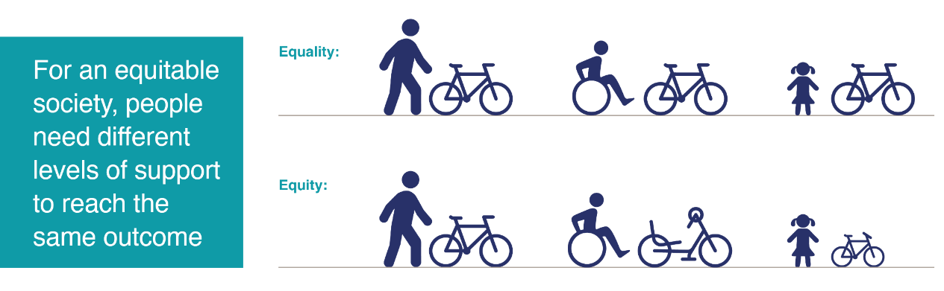
Whilst equality means providing for everyone in equal terms, equity means tailoring provision based on the different needs of different people. Equity is necessary to achieve equal outcomes. Moving away from the idea of equal provision, equity has been increasingly embraced by progressive transport authorities and organisations across the globe.

Foreword
At Sustrans we believe that how we travel should help create happier lives and healthier places for everyone. Sustrans is here to help people walk, wheel and cycle more – and feel better connected and healthier from doing so.
But in a car-dependent society not everyone can. And usually, those people that suffer the worst effects of car dependency are those who are already experiencing disadvantage elsewhere in life. For example, if you are poor and/or from an ethnic minority background, your children are more likely to be killed by traffic, you are more likely to have your life shortened from breathing air poisoned by car fumes, and you are more likely to have no local green or blue space.
To be for everyone, we have to redress this inequity. This is one very good reason why the issue of equity sits at the heart of who we are and what we do.
There is a second good reason: inequity can be embedded in the solutions to the problem. For example, good public realm, decent green space, and quality cycle routes are typically found in more affluent areas. And this infrastructure has historically been designed by men, so it will tend to serve the journeys typically made by men, and it can help explain why walking routes might be poorly lit – personal security at night being less of a concern and reality for men than women. Similar and worse inequities are too often experienced by disabled people, older and younger people, and LGBTQ+ communities.
For years we have been determined that Sustrans will be part of the solution by making affordable active travel options accessible to everyone. In 2019 the Board of Trustees agreed four ‘For Everyone Principles’ that speak to the need to embrace diversity and ensure inclusion in all that we do – from the delivery of our projects externally, our volunteering, and to every aspect of how we operate internally.
We have made progress, but we have certainly not done enough, and indeed our third For Everyone Principle warns against complacency. An audit earlier this year by the Employers Network for Equity & Inclusion (enei) identified that we still have much to do internally to become a more diverse and inclusive place to work. And we know that there is much we can do to deliver more equitable work externally.
The enei report called for a more systematic and strategic approach. This Strategic Framework is just that, setting out nine clear areas of focus – six internal and three external. It has been developed with our organisation and has the full support of the Board and the Executive team. It will guide our day-to-day work and inform our business planning process and our forthcoming Strategy Review.
A big thank you to Tiffany Lam for her excellent work in producing this Framework, and to everyone across Sustrans who has contributed. We will keep getting things done together and keep learning as we work to become a charity for everyone.

Moray Macdonald Xavier Brice
Sustrans Chair Sustrans CEO

Executive Summary
1
Document title over one line, maximum 15 words text text text text text
00 Month 2019
At Sustrans, our mission is to make it easier for everyone to walk, wheel and cycle. As the largest UK active travel charity, we can play a key role in making active travel more equitable, diverse and inclusive. Our ambition to be an organisation for everyone is reflected in our two external strategic priorities: Paths for Everyone and Liveable Cities and Towns for Everyone.
This For Everyone Strategic Framework is a living document that outlines our strategic approach to For Everyone internally and externally over the next five years. It presents a critical opportunity for us to demonstrate leadership by advancing equity, diversity and inclusion (EDI) in the UK transport sector.
There are three components of the strategic framework:
- Internal: Our approach to becoming a more diverse and inclusive organisation.
- External: Our approach to embedding EDI in our external work (delivery and campaigning).
- Enablers: Four enablers underpin both sides of the strategic framework to enable implementation:
- Leadership & accountability
- Engagement
- Monitoring, evaluation & learning
- Fundraising
The internal and external dimensions are structured around areas of focus, each with key outcomes. This is illustrated below in Tables 1 and 2.
The strategic framework has guided the business planning process between October 2023 and February 2024, as all directorates have prioritised one or two areas of focus and embedded actions to drive key outcomes in their 24/25 business plans. The strategic framework will evolve with and inform the wider Sustrans Strategy Review in 2024.
Table 1. Internal: Areas of focus and key outcomes
Area of focus  2  Document title over one line, maximum 10 words text text  00 Month 2019  3  Document title over one line, maximum 15 words text text text text text  00 Month 2019  4  Document title over one line, maximum 10 words text text  00 Month 2019  5  6  7 | Key outcomes
Employee lifecycle | - Increased diversity data collection and analysis.  Increased representation of women, disabled people and people of colour, particularly in senior leadership roles.  Increased feelings of inclusion, particularly among women, disabled people and people of colour.  Increased trust between senior leadership, HR and colleagues.  Increased accessibility and inclusion in recruitment process.
Leadership & Governance | - Improved senior leadership and oversight of For Everyone agenda.  Increased clarity and focus on For Everyone objectives and actions across the organisation.  Strengthened governance of EDI groups and colleague networks, including increased synergies between EDI groups, colleague networks and the wider organisation.
Learning & Development | - Enhanced and more strategic EDI training offer.  Increased understanding of EDI issues – both internal and external.  Improved accessibility of new Learning Management System (LMS).
Policies | - Increased consistency across all our policies, in terms of format, style and tone.  Improved EDI policies to reflect best practice and commitment to our colleagues.  Increased capacity for conducting Equality Impact Assessments of all our policies.
Culture | - Increased culture of accountability, including increased confidence and capability to have difficult conversations with and between colleagues.  - Increased culture of mutual respect that embraces diversity.  - Improved processes for raising concerns.  - Improved integration of EDI into day-to-day work and culture.
Communication | - More regular communication about the For Everyone agenda from senior leaders.  - Increased credibility and transparency in communications about For Everyone.  - Increased inclusivity and accessibility across our internal and external communications.

Table 2. External: Areas of focus and key outcomes
Area of focus  2  Document title over one line, maximum 10 words text text  00 Month 2019  3  Document title over one line, maximum 15 words text text text text text  00 Month 2019  4  Document title over one line, maximum 10 words text text  00 Month 2019  5  Document title over one line, maximum 15 words text text text text text  00 Month 2019  6  Document title over one line, maximum 10 words text text  00 Month 2019  7  Document title over one line, maximum 15 words text text text text text  00 Month 2019 | Key outcomes
Safety and Wellbeing | - Improved perceptions and experiences of safety, particularly for women, girls and LGBTQ+ people, on the National Cycle Network and in cities and towns across the UK.  Improved air quality, particularly in areas with the highest levels of traffic-related air pollution.  Healthier and safer streets that increase opportunities for outdoor activity by vulnerable communities.
Accessibility | - Improved accessibility of the National Cycle Network, particularly for disabled and neurodivergent people.  - Increased cultural accessibility of the National Cycle Network, particularly for communities of colour.  - Increased access to everyday services and amenities that help people to live well including jobs, education, shops, green space and public transport.  - More inclusive walking, wheeling and cycling routes and networks to make these journeys easy, safe and convenient.
Economic Inclusion | - Increased viability of active travel for people with low or no incomes.  - Increased visibility and prioritisation of journey purposes that are overlooked in transport planning (e.g. cycling as work, mobilities of care).  - Uptake of alternative transport appraisal method that factors in equity, public health and environmental goals.  - Increased integration of active travel into local, regional and national approaches to wider economic issues.

Introduction
At Sustrans, our vision is a society where the way we travel creates healthier places and happier lives for everyone. Our mission is to make it easier for everyone to walk, wheel and cycle.
Our strategic priorities are:
- Paths for Everyone: A growing UK network of traffic-free paths for everyone connecting cities, towns and countryside, loved by the communities they serve.
- Liveable Cities and Towns for Everyone: Places that connect us to each other and what we need, where everyone can thrive without having to use a car.
- Improving our Operating Model: Improving how we work and organise ourselves internally to become a fit and nimble charity for everyone.
In all our strategic priorities, ‘for everyone’ is key. This reflects our ambitious For Everyone agenda that is guided by the following For Everyone principles, which were agreed with our Board of Trustees in 2019 and underpin our work:
- The benefits of walking, cycling, wheeling and healthy places are not experienced equitably, so we prioritise work with people and in places that challenges inequity.
- So that we develop solutions that work for everyone, we involve people with different and seldom-heard voices.
- Being for everyone is not a box we can tick. We cannot be complacent, or merely compliant; we have to keep questioning and asking if we can do more.
- We work with others to include everyone. We cannot do this on our own.
Equity, diversity and inclusion (EDI) are the cornerstones of our For Everyone agenda. To deliver on our For Everyone agenda, EDI must be embedded in our work.

The case for our For Everyone agenda
At Sustrans, we know that car dependency is ruining our environment and driving climate change. As noted in our Strategy Refresh 2023, transport produced 27% of the UK’s total emissions in 2019, the majority (91%) of which came from road transport vehicles. This has a disproportionate impact on people from marginalised groups and those living in areas of high deprivation.
To decarbonise transport and achieve net zero, we must get more diverse groups of people walking, wheeling and cycling. If we do not address disparities in active travel, we simply will not be able to deliver Paths for Everyone and Liveable Cities and Towns for Everyone. We will not be able to realise our vision of a society where the way we travel creates healthier places and happier lives for everyone.
As the largest UK active travel charity, we have a critical role to play in making active travel more equitable, diverse and inclusive. We need to ensure that the benefits of our work are more equitably distributed, given the inequalities in walking, wheeling and cycling documented in our 2020 Cycling for Everyone report, our 2022 Walking for Everyone report, our 2023 Disabled Citizens’ Inquiry and our breakthrough Walking and Cycling Index Data Tool.
We believe that being a more diverse and inclusive place to work enables us to deliver greater impact. We can start from within by improving our operating model and structuring our organisation to deliver equitable and inclusive active travel solutions. Besides improving the bottom line, diversity and inclusion in the workplace unlock innovation, improve the quality of decision-making, and enable organisations to attract and retain top talent.
At Sustrans, working for and with communities is at the heart of what we do. To do that well, we need to have a more diverse and inclusive workforce. This will give us the credibility we need to engage meaningfully with the diverse communities we serve across the UK.
When people from all walks of life are involved in decision-making, and when colleagues can bring their full selves to work, we can more effectively design and deliver better walking, wheeling and cycling solutions that benefit people experiencing the worst impacts of car dependency. This will give us a competitive advantage in the UK transport sector.

About this For Everyone Strategic Framework
This For Everyone Strategic Framework is a living document that sets out our strategic approach to For Everyone internally and externally over the next five years. It presents an exciting business development opportunity as well as an opportunity for Sustrans to demonstrate leadership on advancing equity, diversity and inclusion in the active travel and wider transport sector in the UK and beyond.
This strategic framework document is split into three parts:
Internal: The first part sets out our approach to becoming a more diverse and inclusive organisation. It is informed by the Diversity & Inclusion audit conducted by the Employers’ Network for Equality and Inclusion (enei) between November 2022 and March 2023.
External: The second part sets out our approach to embedding equity, diversity and inclusion in our external work, which includes delivery and campaigning. It is informed by a literature review and comparative analysis of transport equity frameworks and plans that have been adopted by local, regional and national governments and organisations working on sustainable transport globally between 2020-2023.
Enablers: The third part sets out four factors that underpin both dimensions of the For Everyone Strategic Framework to enable implementation.
This document concludes with our approach to measuring our progress on implementation.
The structure of the For Everyone Strategic Framework is illustrated in Figure 1 overleaf. The internal and external dimensions are structured around several areas of focus, each with key outcomes over the next five years.
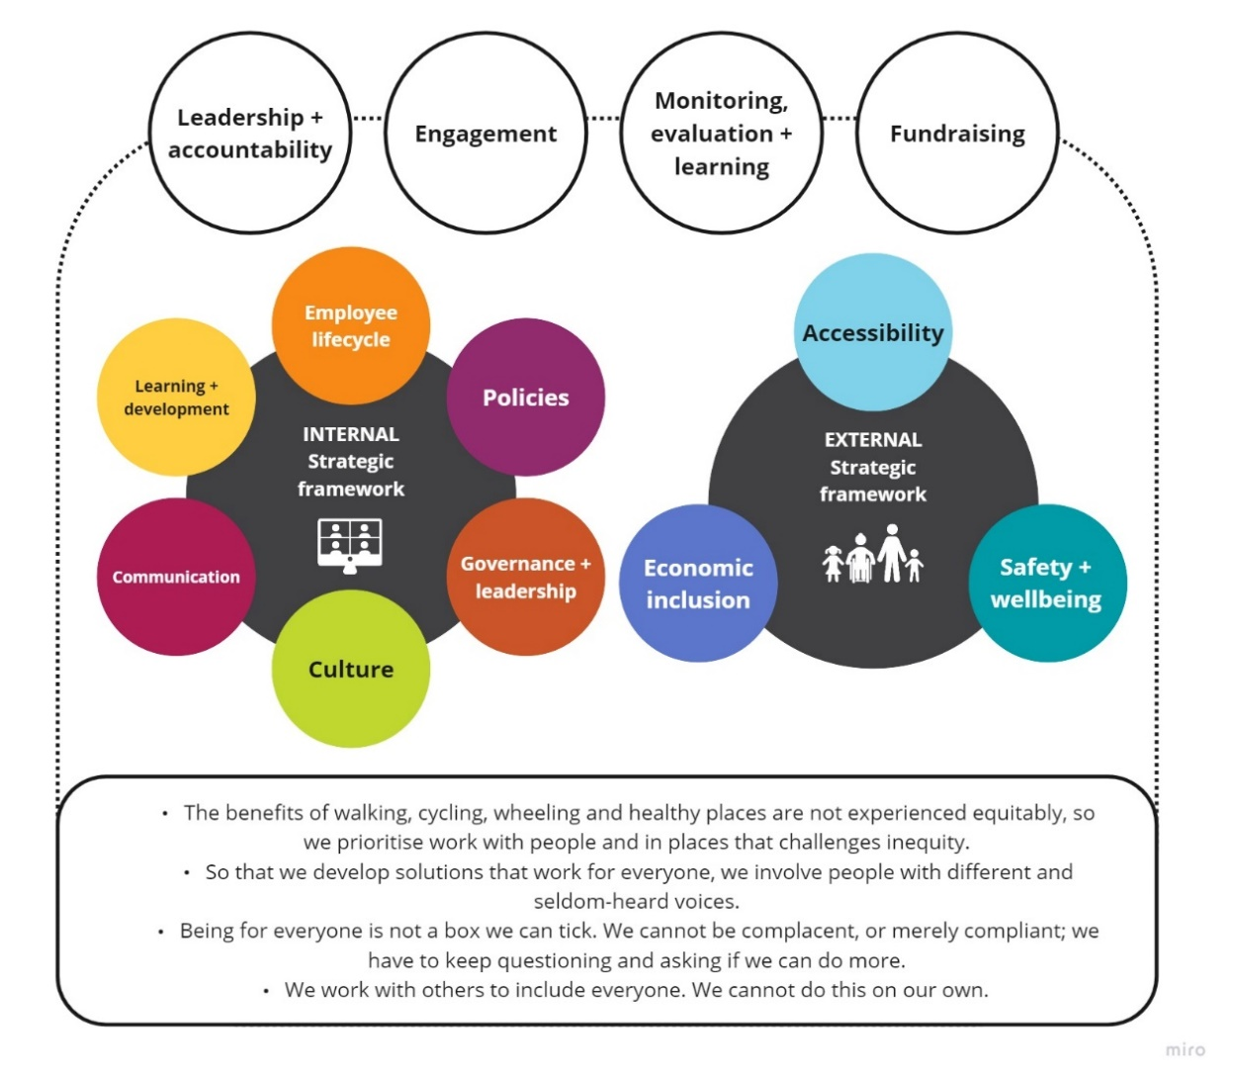
Figure 1. Structure of For Everyone Strategic Framework

Internal
Improving our operating model to be a charity ‘For Everyone’ is one of our strategic priorities. The internal dimension of our For Everyone Strategic Framework speaks to this and is based on findings and recommendations from the Diversity & Inclusion audit that the Employers’ Network for Equality and Inclusion (enei) conducted between November 2022 and March 2023. It is structured around six areas of focus (as illustrated in Figure 2 overleaf):
- Employee Lifecycle
- Leadership & Governance
- Learning & Development
- Policies
- Culture
- Communication
Below is a brief discussion of each of these six areas of focus. It is important to note that wider improvements, beyond improvements from an EDI lens, are needed across these six areas to lead to our desired outcomes.
Our For Everyone: Internal Action Plan is an internal document that sets out actions we will take across these six areas of focus in the next 0-2 and 3-5 years to drive our key outcomes.

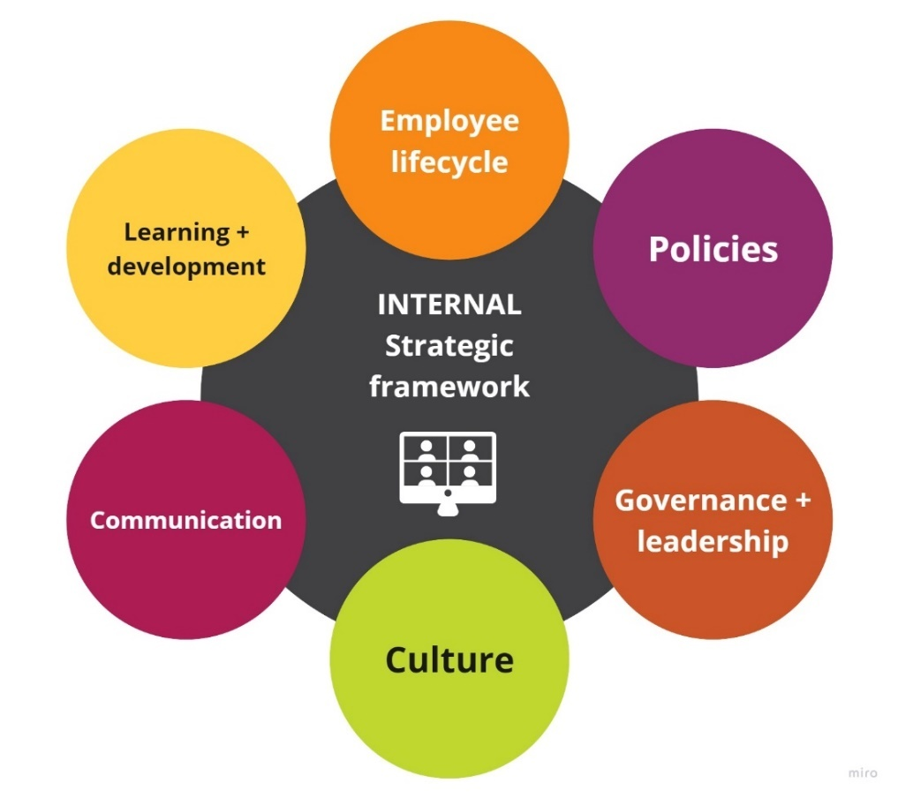
Figure 2. Internal: Areas of focus

Employee Lifecycle
Employee Lifecycle refers to our workforce and covers the entirety of the employee lifecycle, or colleagues’ experiences of working at Sustrans, beginning with attraction and recruitment, retention, promotion and attrition. We have five key Employee Lifecycle outcomes:
- Increased diversity data collection and analysis.
- Increased representation of women, disabled people and people of colour, particularly in senior leadership roles.
- Increased feelings of inclusion, particularly among women, disabled people and people of colour.
- Increased trust between senior leadership, HR and colleagues.
- Increased accessibility and inclusion in recruitment process.

Governance & Leadership
Governance & Leadership refers to governance and leadership structures to drive the For Everyone agenda. These structures are nascent and need to be firmed up. We have three key Governance & Leadership outcomes:
- Improved senior leadership and oversight of For Everyone agenda.
- Increased clarity and focus on For Everyone objectives and actions across the organisation.
- Strengthened governance of EDI groups and colleague networks, including increased synergies between EDI groups, colleague networks and the wider organisation.

Learning & Development
Learning & Development refers to training and other learning and professional development opportunities at Sustrans. We have three key Learning & Development outcomes:
- Enhanced and more strategic EDI training offer.
- Increased understanding of EDI issues – both internal and external.
- Improved accessibility of new Learning Management System (LMS).

Policies
Policies refers to our HR policies, particularly ones related to EDI. We have three key Policies outcomes:
- Increased consistency across all our policies, in terms of format, style and tone.
- Improved EDI policies to reflect best practice and commitment to our colleagues.
- Increased capacity for conducting Equality Impact Assessments of all our policies.

Culture
Culture refers to the organisational culture of Sustrans. We have four key Culture outcomes:
- Increased culture of accountability, including increased confidence and capability to have difficult conversations with and between colleagues.
- Increased culture of mutual respect that embraces diversity.
- Improved processes for raising concerns.
- Improved integration of EDI into day-to-day work and culture.

Communication
Communication refers to the ways in which we communicate and engage with our colleagues on EDI issues. We have three key Communication outcomes:
- More regular communication about the For Everyone agenda from senior leaders.
Increased credibility and transparency in communications about For Everyone.
Increased inclusivity and accessibility across our internal and external communications.

External
In line with our strategic priorities that guide our delivery work, Paths for Everyone and Liveable Cities and Towns for Everyone, we want our work to raise ambition and contribute to a more equitable and inclusive transport system, in particular active travel, in the UK.
The external dimension of the For Everyone Strategic Framework is informed by a comparative analysis of global transport equity frameworks and plans that have been widely adopted at the local, regional and national levels within the past three years. These frameworks and plans use different language and imagery to describe what an equitable transport system looks like and how to create one. Beneath these differences lies a growing consensus on what to prioritise.
These priorities can be distilled into three areas of focus, which structure the external dimension of the For Everyone Strategic Framework (Figure 3 overleaf):
- Safety & Wellbeing
- Accessibility
- Economic inclusion
These areas of focus are discussed below. Each area of focus has a core action that we will take across the organisation to drive the key outcomes. In addition to these three core actions, each directorate has prioritised key outcomes and identified further actions they will take to contribute to those outcomes in their 24/25 business plans. Actions have also been embedded in Sustrans Approaches, a forthcoming document that sets out how we work and the services we deliver.
It is important to recognise the strengths and limitations of our actions. Our actions will directly contribute to some outcomes (e.g. improved accessibility of the National Cycle Network for disabled and neurodivergent people). However, other outcomes, particularly those under the economic inclusion area of focus, are wider, longer-term and beyond our direct control. As such, we will need to use our voice and work in partnership with other organisations to influence wider systemic changes.
This is consistent with our fourth For Everyone principle –
We work with others to include everyone. We cannot do this on our own.
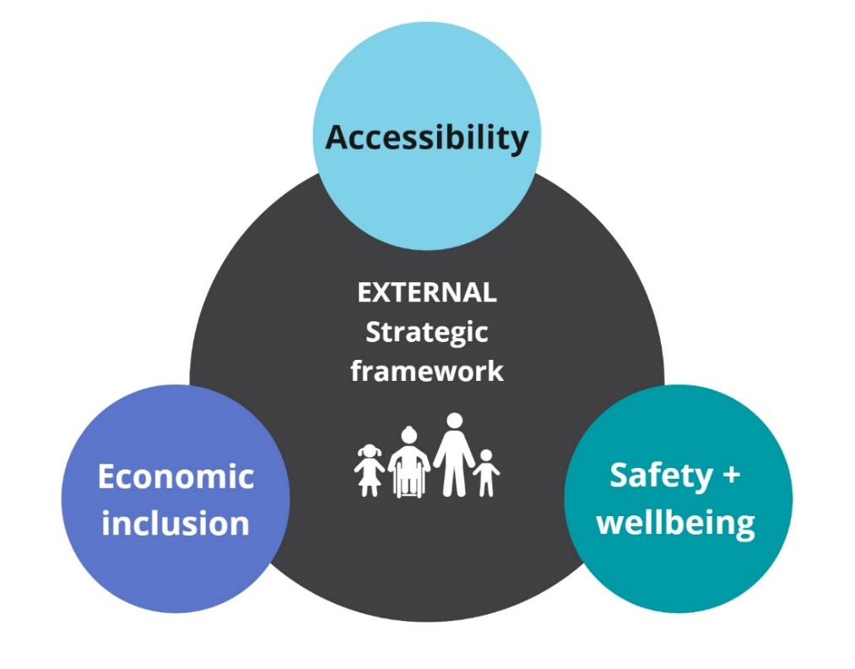
Figure 3. External: Areas of focus

Safety & Wellbeing
We are working towards the following three safety & wellbeing outcomes. Our engagement and delivery work, coupled with using our voice to influence change, will help us deliver the first and third outcomes. The second outcome is one where our contribution will be more indirect, given the variables that affect air quality.
- Improved perceptions and experiences of safety, particularly for women, girls and LGBTQ+ people, on the National Cycle Network and in cities and towns across the UK.
- Improved air quality, particularly in areas with the highest levels of traffic-related air pollution.
- Healthier and safer streets that increase opportunities for outdoor activity by vulnerable communities.
Core action: Create a standard approach to gender safety audits and apply it to projects.

Accessibility
Accessibility is an area of focus where our work will achieve more of our desired outcomes, particularly the first, second and fourth ones. We can build on the good work we have already done to make walking, wheeling and cycling more accessible by working towards the following four outcomes:
- Improved accessibility of the National Cycle Network, particularly for disabled and neurodivergent people.
- Increased cultural accessibility of the National Cycle Network, particularly for communities of colour.
- Increased access to everyday services and amenities that help people to live well, including jobs, education, shops, green space and public transport.
- More inclusive walking, wheeling and cycling routes and networks to make these journeys easy, safe and convenient.
Core action: Create a standard approach to accessibility audits and apply it to projects.

Economic inclusion
Compared to the previous two areas of focus, economic inclusion is a longer-term, wider impact beyond the outcomes we are likely to achieve ourselves. Most of our work in this area will therefore be more indirect, via influence.
However, there are existing projects in the nations/regions that have potential to directly contribute to some of these outcomes. For example, the E-Move project in Wales, which is one of the Welsh Government’s gender budgeting pilots, will have a more direct contribution to the fourth outcome.
The four economic inclusion outcomes we are working towards are:
- Increased viability of active travel for people with low or no incomes.
- Increased visibility and prioritisation of journey purposes that are overlooked in transport planning (e.g. cycling as work, mobilities of care).
- Uptake of alternative transport appraisal method that factors in equity, public health and environmental goals.
- Increased integration of active travel into local, regional and national approaches to wider economic issues.
Core action: Deliver the recommendations outlined in our 2022 Cost of Living report.

Enablers
Four key enablers underpin the implementation of both dimensions of the For Everyone Strategic Framework:
- Leadership & Accountability: Senior leadership is essential to signal to colleagues, stakeholders and the wider public that Sustrans is committed to equity, diversity and inclusion. We will develop reporting mechanisms for teams to share For Everyone progress updates and hold ourselves accountable.
- Engagement: Engagement with colleagues is necessary to implement this For Everyone Strategic Framework. Externally, we need to do inclusive and meaningful engagement with diverse communities.
- Monitoring, Evaluation & Learning: Our approach to For Everyone must be evidence-based. Our Research and Monitoring Unit (RMU) will lead work to improve our diversity data collection and analysis (internally and externally).
- Fundraising: Some elements of the external dimension of this Framework align with and can help frame areas of delivery work we are proactively seeking funding for. Other elements present opportunities to diversify our funding sources and develop new work streams.

Next steps
We will review and update our For Everyone Strategic Framework in two years (2026), but it is likely that the external dimension will evolve earlier as we begin the Sustrans Strategy Review in 2024. This strategic framework will also inform the wider Sustrans Strategy Review.

Our Learning Approach
We will understand our progress on implementing the For Everyone Strategic Framework in an iterative and reflective way, with support from RMU. This is consistent with our always learning Sustrans value and our third For Everyone principle,
Being for everyone is not a box we can tick. We cannot be complacent, or merely compliant; we have to keep questioning and asking if we can do more.
The implementation of the For Everyone Strategic Framework will require changes in our ways of working. Measuring how processes change does not lend itself to easily quantifiable metrics. Furthermore, achieving the outcomes for the external side will require wider systems change, including things beyond Sustrans’ control or remit. This creates challenges around attribution and measuring our impact.
Therefore, all directorates will keep an action log, review and report on it every 6 months to assess:
- Did we do what we said we would do?
- Did what we do lead to our desired outcome(s)?
- What can we do better or differently?
- What will we not do?
This learning approach will enable us to:
- Ensure that we are delivering activities to drive our desired outcomes.
- Create mechanisms and structures to monitor and learn from our work to ensure we are not perpetuating inequities.
- Make any corrective intervention as and when necessary.
RMU’s measurement will focus on outputs to ensure that internal activities and external projects are being delivered in line with both expectations of what we want to achieve and best practice. Indicators will be developed as an when appropriate.

UK Public General Acts. Equality Act 2010. https://www.legislation.gov.uk/ukpga/2010/15/part/2/chapter/1.
Crenshaw, K. (1989). Demarginalising the intersection of race and sex: A Black feminist critique of antidiscrimination doctrine, feminist theory and antiracist politics. University of Chicago Legal Forum, 1(8): 139-167.
Scottish Government. (2022).
Council of European Municipalities and Regions. (2023).
New Economy Organisers Network. (2015). Power and Privilege: A handbook for political organisers. https://theedgefund.files.wordpress.com/2013/04/neon-power-and-privilege-intro-guide.pdf.
New Economy Organisers Network. (2015).
Sørensen, A.B. (1996). The Structural Basis of Social Inequality. American Journal of Sociology, 101(5): 1333-1365. https://www.jstor.org/stable/2782357.
Women’s Budget Group. (2021). Towards Gender-Inclusive and Sustainable Transport Systems. https://wbg.org.uk/analysis/uk-policy-briefings/towards-gender-inclusive-and-sustainable-transport-systems/.
UKPIA. (2021). The Future of Mobility in the UK. https://online.flippingbook.com/view/609189063/.
CPRE. (2021). Every village, every hour 2021 buses report. https://www.cpre.org.uk/resources/every-village-every-hour-2021-buses-report-full-report/.
McKinsey & Company. (2020). Diversity wins: How inclusion matters. https://www.mckinsey.com/featured-insights/diversity-and-inclusion/diversity-wins-how-inclusion-matters.

