Candidate Information

Project Officer - Kent Community Rail Partnership

Salary: | Grade F: £28,831 per annum, pro rata for part time hours
Hours: | 15 hours/ 2 days per week (with a potential to increase, subject to funding)  We are happy to discuss working hours to suit individual circumstances. There is a possibility of further funding available to increase hours for the project.
Contract: | Contract to end August 2025 (or 1 year from start date)
Disclosure: | Enhanced DBS clearance is required for this position as the post holder will be working with children in educational settings
Base: | Working mostly from home, with a base to visit at Maidstone West Station. Focus on Swale, including the Isle of Sheppey
Travel: | The role will require travel throughout Kent including the Isle of Sheppey, with some travel outside of the County. The post holder will be prepared to travel sustainably (walk, cycle and/or use public transport) for the majority of daily work journeys.  Some evening and weekend work will be required.

Job or Project Specific Information

To work with Southeastern, Medway Council and other partners in promoting and developing Community Rail Partnerships (CRPs) across the three railway lines in Kent- the Kent Downs line, Swale Rail and the Medway Valley line. The post holder will work in a small team, building strong partnerships with communities, schools, workplaces and other local organisations and volunteer groups.

The focus for this role will be on the Swale Rail line alongside supporting colleagues with project-wide objectives of delivering passenger growth and improvements to rail services and station environments. The project follows the four pillars of the community rail strategy and runs a variety of activities to improve stations, bring people to using rail for everyday journeys and to encourage sustainable and active travel to and from stations.
The Officer will report directly to the local Sustrans Project Manager as well as maintaining relationships with a volunteer line Chairperson, Southeastern partners, and the Chairman and other volunteer members of the partnership.

Where this role sits in the structure:

Job Description - About the Role

Overview

This is an exciting opportunity to work in an award-winning team, being able to use event managements skills, good communication and creativity to promote rail travel. Working with Southeastern and other partners in Kent to improve stations and encourage people to use rail for their everyday journeys- helping community rail to flourish.
The Officer will help to deliver the CRP action plan, which is a combination of mini- projects submitted by CRP members every year as well as several core activities. They will offer a tailored package of support to station adopter groups, and work with various community and school groups to deliver rail safety training, as well as providing support and advice. Bringing new volunteers onboard and supporting them in their experience with the partnership is a key part of the role.
By understanding the diverse range of people within the project area, the Officer will develop and engage communities in fun, innovative and informative activities. They will share resources and work with communities to reduce car use to and from stations, increasing opportunities for walking, wheeling and cycling and helping increase passenger numbers on the rail services.
The Officer will encourage maximum community involvement, work with the local team to grow the membership of the CRP and bring together different interested parties to support the programme in delivering the four pillars:
- Providing a voice for the community
- Promoting sustainable and healthy travel
- Brining communities together, supporting diversity and inclusion
- Supporting social and economic development
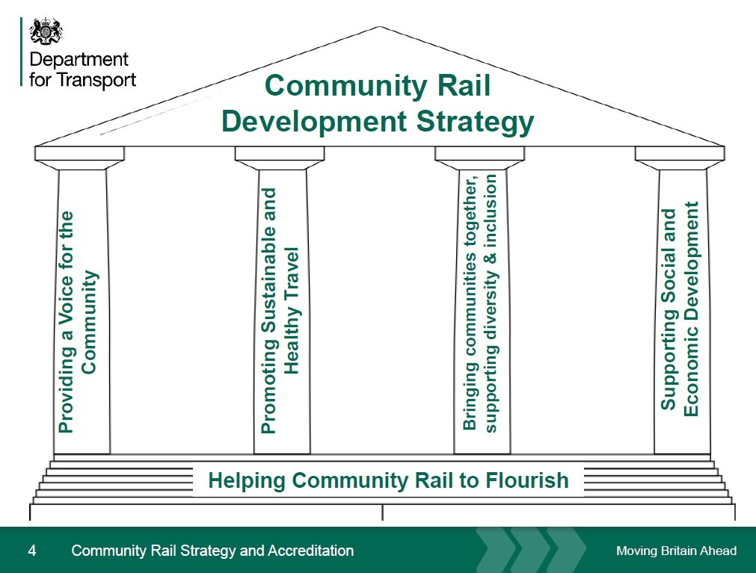

Where this role sits in the structure | Reporting into the Delivery Project Manager  Working closely with other CRP Sustrans Officers and other delivery officers and project managers across the south team.  Externally the Officer will engage directly with the Community Relations Manager at Southeastern, the line chair for Swale rail line and the CRP chair.

Key Responsibilities
We don’t expect anyone to be an expert in all these areas and as long as you meet the person specification we can train you in any gaps.

Responsibilities may include:
- To encourage the integration of rail services with other modes of transport including walking, wheeling and cycling, local bus services, taxis and community transport.

- To develop and expand the Southeastern “Station Adoption” and Network Rail “Community Schemes” programmes, by seeking further individuals and community groups who are interested in improving their local station’s environment.

- To be the main source of advice and support to such groups and provide a link to the railway industry. These schemes will initially be focused at stations on the Swale rail line, but groups concerned with other stations on the Southeastern network should also be assisted.

- To contribute to the content and maintenance of the Community Rail Partnership web pages and social media outlets as well as developing publicity materials and distribute as required.

- To work with the train operators to develop initiatives that encourage increased rail usage and improve the number of stations that are accessible to all.

- To monitor the outcomes of any initiatives and provide regular reports to the CRP, main funders and any other appropriate body.

- To organise and attend Steering Group, Stakeholder and line meetings, as well as producing agendas and minutes as required.

- To encourage maximum community involvement in partnership projects and to ensure that each partnership is inclusive and genuinely reflects the profile of the communities served by the line. This includes the recruitment and support of volunteers across the project.

Person Specification
The following criteria sets out the method by which the skills, knowledge and experience will be assessed against. Our website has a useful guide about how to make a great job application.

 | Application Form | Interview
Specific experience required
Working with children and young people
Working with community groups
Partnership working with local authorities or similar partners
Leading group workshops, activities and events planning
Engagement with a diverse range of people
Skills and Abilities
Ability to confidently communicate to different audiences by various means
Organising and leading events and activities
Adaptable and solutions driven
Motivate and enthuse others
Work independently and plan and prioritise own workload
Work well in a team
Specific knowledge required
Knowledge of the local area
Understanding of the benefits of active and sustainable travel, particularly rail
Basic understanding of safeguarding

This document does not form part of the contract of employment but does outline our expectations.
If we need to amend this document in the future we will consult with the post holder before doing so.

Everyone at Sustrans

Our values guide us in everything we do:
- Including everyone
- Having the courage to question
- Acting local, thinking big
- Getting things done, together
- Always learning.

- Sustrans has clear health and safety policies and it is essential that all our colleagues follow these. Very often our teams come into contact with young people through schools work or community engagement so it is everyone’s responsibility at Sustrans to comply with our Safeguarding policies.

- One of our key strategic goals is to be a charity “for everyone”, building a more diverse and inclusive Sustrans. We recognise there is much more we can do to bring together diverse life experiences and voices to enable us to more fully understand, access and represent the communities we work in. Everyone at Sustrans should support this goal and follow our Equality, Diversity and Inclusion policies and procedures.

- Sustrans asks that all our employees develop their skills, knowledge and experience through training and personal development activities. Sustrans will support you with clear objectives and a supportive management culture - our teams tell us that one of the great things about working for Sustrans is the learning and knowledge sharing opportunities.

- It is very important that our colleagues are happy and able to work with IT systems - we use Microsoft programmes and other databases every day (we will train you on our bespoke systems).

- It is also important that everyone at Sustrans supports and follows with the charity’s guidance on branding/key messages and contributes towards raising Sustrans’ profile.

- Everyone at Sustrans is required to work their contracted hours and record their time – if extra hours are worked then we can take time off in lieu.

- We ask that everyone in Sustrans helps us to develop new opportunities for funded work and builds excellent relationships with our delivery partners and stakeholders.

- Two of our values are we get things done, together and we’re always learning. Managers often require their teams to get involved in activities that are outside of their job descriptions as we feel this is one of the ways you can learn on the job, develop new skills, make new contacts and progress your career with Sustrans.

