Candidate Information

Project Delivery Assistant

Salary: | Grade D: £ 23,193 per annum pro rata
Hours: | Part time hours are 22.5 hours (3 days) per week  We are happy to discuss working hours to suit individual circumstances.
Contract: | Contract to 31st October 2024 (with possible extension)
Disclosure: | Enhanced DBS required for this position as the post holder may work with children in educational settings and vulnerable adults
Base: | Stockton Walking and Cycling Hub or Darlington
Travel: | This role will involve regular travel most weeks in their area. We may occasionally need you travel further during your work including occasional overnights stays.
 | A key part of being the Charity that makes it easier to walk and cycle is that most colleagues cycle, walk, wheel or use public transport for the majority of their work journeys. We support this with access to a Sustrans pool bicycle and National Standards Cycling Training.

Project Specific Information

Our Active Travel Hubs in the Tees Valley provide helpful services and interventions to make walking and cycling the natural choice for shorter journeys in the Tees Valley. Building on our success over the past 12 years, this is an exciting and ambitious project part of the UK’s largest network of Active Travel Hubs, working together to transform how Tees Valley residents travel for their everyday journeys.
This varied role would see you working in partnership with the local authority, communities, schools, businesses, volunteers and third sector organisations, to remove barriers to transport, increase levels of public health and wellbeing, and protect our local environment.
Due to additional funding opportunities a delivery assistant is required to enable us to deliver valuable services to our beneficiaries with the ultimate aim of increasing active travel in The Tees Valley. The post holder will provide support to the project team, project beneficiaries, and volunteers for three days a week our active travel hub in Stockton or Darlington. Contracts are until October 2024 with possible extension.

Where this role sits in the structure

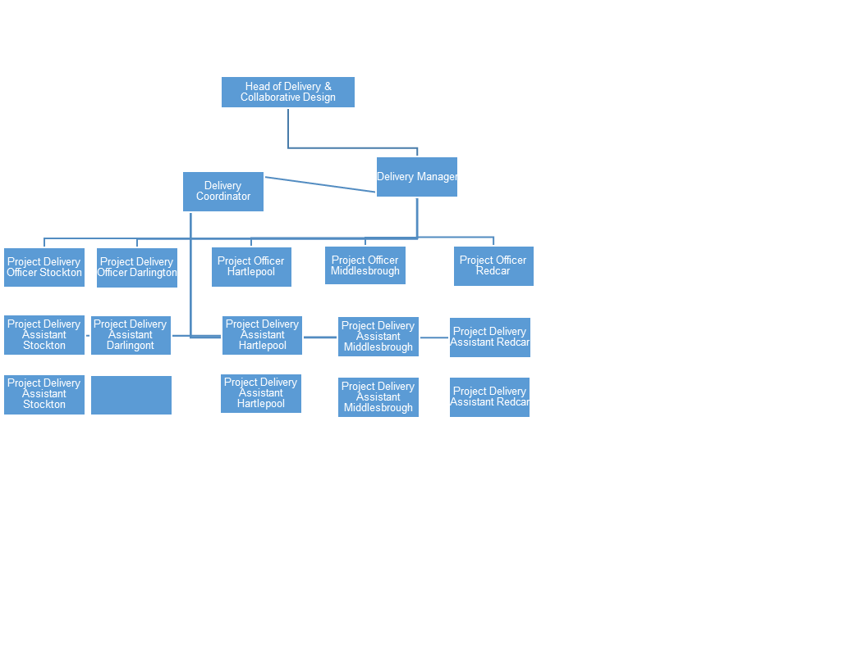

Job Description - About the Role

Overview

Working with the delivery coordinator and a project officer to assist with delivery of a variety of Smarter Choices projects designed to promote active travel in communities, workplaces and education establishments. The post holder will also support the recruitment and development of volunteers in their area.

Where this role sits in the structure | Reporting into the Delivery Manager and Delivery Coordinator, England North  Working closely with the Project Delivery Officer.  This role does not have line management responsibility.

Key Responsibilities
- To work in partnership with the public sector, voluntary organisations, local communities and employers to deliver a range of initiatives that encourage and enable residents, education establishments and businesses to benefit from increased levels of activity through walking and cycling.
- To delivery of a series of initiatives that promote active travel working alongside colleagues and partners.
- To support the Project Officer in the management and support of volunteers working on project delivery in the Hub.
- To contribute to marketing and communication activities, e.g. through assistance at sustainable travel road show events, distribution of information materials etc.
- To delivery of a series of initiatives that promote active travel working alongside colleagues and partners.
- To support the engagement of local communities and address the key barriers identified to cycling and walking, including confidence to cycle and walk, knowledge of routes and for cycling, having a road worthy cycle.
- To help aid measurement and evaluation of project activities.
- To assist in the general day to day running of the Active Travel Hub including opening and closing duties.
- Under the guidance of the Head of Delivery, to be responsible for personal and participant health and safety following set protocols.
- To ensure compliance with the internal and external policies, procedures and legislation including data protection.
- To undertake other duties as appropriate to the post.

We don’t expect anyone to be an expert in all these areas and as long as you meet the person specification we can train you in any gaps.

Person Specification
The following criteria sets out the method by which the skills, knowledge and experience will be assessed against. Our website has a useful guide about how to make a great job application.

 | Application Form | Interview
Specific experience required
Experience of working with volunteers or volunteering in a community project | ü
Skills and Abilities
Ability to work as part of a team and alone in a reliable and efficient manner |  | ü
Good communication skills both verbal and written | ü | ü
Highly self-motivated with the ability to engage with others | ü | ü
Good organisational skills and a willingness to learn | ü | ü
Ability to plan and monitor workloads | ü
Specific qualifications/ training required
Commitment to work towards the following qualification:  - Cycle leader and volunteer walk leader trained  - Current first aid certificate  - Cycle maintenance qualification |  | Z
Specific knowledge required
Knowledge of effective cycling and walking initiatives |  | ü
Engagement techniques and behaviour change initiatives |  | ü

This document does not form part of the contract of employment but does outline our expectations.
If we need to amend this document in the future we will consult with the post holder before doing so.

Everyone at Sustrans

Our values guide us in everything we do:
- Including everyone
- Having the courage to question
- Acting local, thinking big
- Getting things done, together
- Always learning.

- Sustrans has clear health and safety policies and it is essential that all our colleagues follow these. Very often our teams come into contact with young people through schools work or community engagement so it is everyone’s responsibility at Sustrans to comply with our Safeguarding policies.

- One of our key strategic goals is to be a charity “for everyone”, building a more diverse and inclusive Sustrans. We recognise there is much more we can do to bring together diverse life experiences and voices to enable us to more fully understand, access and represent the communities we work in. Everyone at Sustrans should support this goal and follow our Equality, Diversity and Inclusion policies and procedures.

- Sustrans asks that all our employees develop their skills, knowledge and experience through training and personal development activities. Sustrans will support you with clear objectives and a supportive management culture - our teams tell us that one of the great things about working for Sustrans is the learning and knowledge sharing opportunities.

- It is very important that our colleagues are happy and able to work with IT systems - we use Microsoft programmes and other databases every day (we will train you on our bespoke systems).

- It is also important that everyone at Sustrans supports and follows with the charity’s guidance on branding/key messages and contributes towards raising Sustrans’ profile.

- Everyone at Sustrans is required to work their contracted hours and record their time – if extra hours are worked then we can take time off in lieu.

- We ask that everyone in Sustrans helps us to develop new opportunities for funded work and builds excellent relationships with our delivery partners and stakeholders.

- Two of our values are we get things done, together and we’re always learning. Managers often require their teams to get involved in activities that are outside of their job descriptions as we feel this is one of the ways you can learn on the job, develop new skills, make new contacts and progress your career with Sustrans.

