School Travel Survey

We would appreciate your time in completing this short survey to support our School Travel Plan. Your feedback will help us improve travel options,

supporting the health and well-being of students and staff. The survey will take no more than 5 minutes. Thank you for your help!

**Name of school:** ……………………………………………………………………………………

**Date:** …………………………………………………………………………………………….……

**What year group is your child in?** ………………………………………………………………

1. How long is your trip to school?

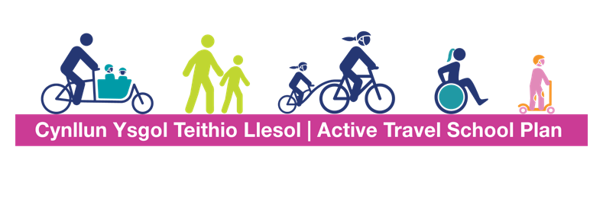

0-1 miles

1-3 miles

3-5 miles

5+ miles

1. How do you (or how does your child) normally travel to school?

Walk / wheel  Car/taxi

Scoot  Bus

Cycle  Other

If you ticked other, please specify (e.g. walking bus, park and stride, etc.)

…………………………………………………………………………………………………………………………………

………………………………………………………………………………………

1. How would your child prefer to travel to school?

Walk / wheel  Car/taxi

Scoot  Bus

Cycle  Other

If you ticked other, please specify.

…………………………………………………………………………………………………………………………………

………………………………………………………………………………………



1. What influences your main type of travel you use to and from school? Please tick all that apply:

Convenience  Time savings

Cost  Disability of parent/guardian/child

Health reasons  Safety

Social reasons  Onward travel to work out of town Environmental reasons  Other

If you ticked other, please specify.

……………………………………………………………………………………………………………………………………

……………………………………………………………………………………

1. Do you have any concerns about the route to your child’s school? Are there any improvements that could be made?

E.g. a particularly busy road, a junction, parked cars or a blind corner.

……………………………………………………………………………………………………………………………………

……………………………………………………………………………………

1. If you travel to school by car, what would enable or encourage you to walk/wheel, cycle, use a bus or car share on your journey to school?

……………………………………………………………………………………………………………………………………

……………………………………………………………………………………

Thank you for your time!

**Did you know?**Kids under 5 need 3 hours of activity a day, ages 5-18 need an hour, and adults should aim for 30 minutes!

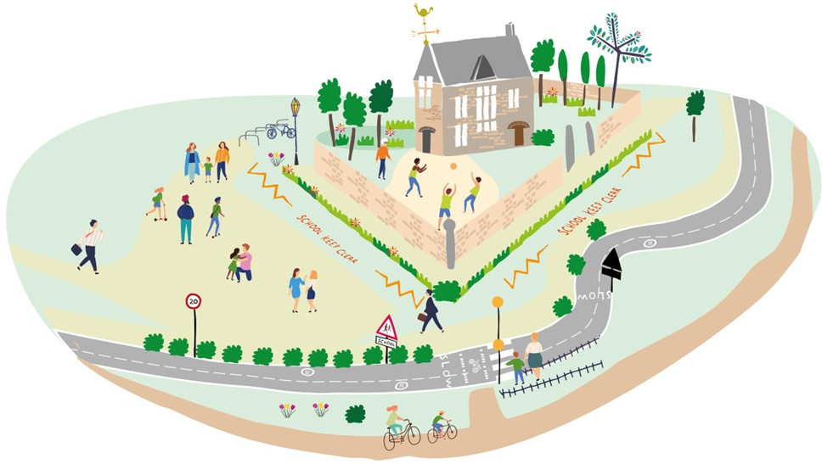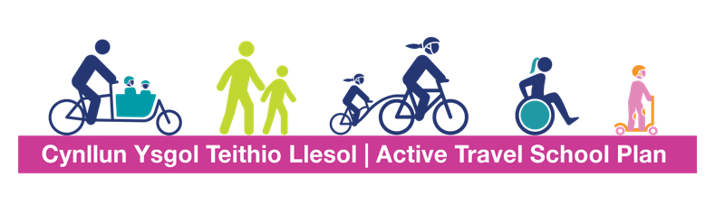

**Ever thought about parking a bit further and walking the last 5 minutes?**

It's a great way for kids to get some exercise and helps cut down on traffic and pollution near school!

